# Grid II

## Column show in grid

The grid view will show ONLY columns in order and format specified below.

Column Min length specify the amount of character shows in the screen, if the data is longer, then it will be shown as tool-tip when mouse is moving over the text.

The grid shall be Excel style, which will be mainly used in PC environment.

|  |  |  |  |  |  |
| --- | --- | --- | --- | --- | --- |
| AM DB Fieldname | JSON field name from WorkOrder object | descr. English (column title) | descr. German | field type | min length |
| STATUS | WorkOrderStatus | Status | Status | string | 16 |
| substatus | SubStatus | Substatus | Substatus | string | 16 |
| visitreason | VisitReasonCode, description from master data  Example:  03 = Warranty | Visit Reason | WO Grund | String | 16 |
| dept | DeptId, description from master data  Example:  A0123 = MB PKW | Department | Abteilung | string | 16 |
| stype | TransactionType | Transaction type | Tras.Typ | string | 2 |
| WRKORDNO | WorkOrderNo | Workorder No | Auftr.No. | number, no decimal, no thousand grouping digit | 10 |
| PAYER | PayerInfo | Payer | Zahler | string, all listed | 30 |
| custno | WOCustomer.CustNo | Cust Nr. | KdNr. | number, no decimal, no thousand grouping digit | 10 |
| CONFNAME | ContactFName | Cust Name | Kd V-Name | string | 20 |
| CONLNAME | ContactLName | Cust Lastname | Kd Name | string | 20 |
| LICNO | WOVehicle. LicenseNo | Reg. Nr. | Pol.Nr | string | 20 |
| GSAL.DISTDRIV | Mileage | Mileage | Km Stand | number, no decimal, thousand grouping digit needed | 10 |
| skey | WOVehicle.SearchKey | Search Key | Such ID | string | 20 |
| serialno | WOVehicle.VIN | VIN | VIN | string | 17 |
| receiver | ServiceAdvisorId, description from master data  Example:  R0230 = Duong Le | Service advisor | Kd Berater | string | 10 |
| servd | ServiceDate | Servcie date | Serv.Dat | date | dd.mm.yyyy |
| FREGD | WOVehicle .FirstRegDate | 1.reg | 1.Inv | date | dd.mm.yyyy |
|  | CourtesyCarInfo | Cortesy Car | Ers.Wg | List Licno | 20 |
| Subcontractor Nr/Name | SubContractorInfo | Subcontractor | Unter Lieferant | string - limit (All in Mouseover) |  |
| Place of damage / Referenz | PlaceOfDamage | Reference | Ref. | text - limit (all in Mouseover) | Not found |
| next servcie | WOVehicle. NextServiceDate | N. Service | N.Service | date | dd.mm.yyyy |
| letzte MFK | WOVehicle.NextMOTDate | N. Inspect | N.MKF | date | dd.mm.yyyy |
| letzer We-Besuch | WOVehicle. PreviousServiceDate | P. Service | L. Besuch | date | dd.mm.yyyy |
| note | WOVehicle.VehicleNote | Note | Bemerk. | text | 40 |
| make | WOVehicle.Make | Make | Marke | string | 20 |
| model | WOVehicle.Model | Model | Modell | string | 20 |
| submodel | WOVehicle.Submodel | Submodel | Submodell | string | 20 |
| ESTDELTIME | CheckOutDate | Est. del | Gepl. Ablief. | date / time | dd.MM.yyyy hh:mm |
| RELINQUI | DeliveredBy | Del by | Ablief. Von | string | 10 |
| WOREADYDATE | WorkReadyForInvoiceDate | WO ready | Auftag Ende | date / Time | dd.MM.yyyy hh:mm |
| WOREADYUSER | WorkReadyBy | WO ready user | Auftr. Ende von | string | 10 |
|  | AttachmentFilesCount | no attached files | Anz. Dateien | number | 3 |

## Grid additional Filter

### Filter by Workorder Status

Combo box Workorder Status shall contains selection from API: [/api/ASMaster?command=getWorkOrderStatuses](http://automaster.alliedsoft.hu:9092/api/ASMaster?command=getWorkOrderStatuses)

Send filter value via HTTP header variable WorkOrderStatus

### Filter by Substatus field

Combo box Workorder Sub status shall contains selection from API: [/api/ASMaster?command=getSubStatuses](http://automaster.alliedsoft.hu:9092/api/ASMaster?command=getWorkOrderStatuses)

Send filter value via HTTP header variable SubStatus

### Filter by WO visit reasons

Combo box Workorder Visit reason shall contains selection from API: [/api/ASMaster?command= getVisitReasons](http://automaster.alliedsoft.hu:9092/api/ASMaster?command=getWorkOrderStatuses)

Send filter value via HTTP header variable VisitReasonCode

### Filter by Today workorders

One checkbox for a preset filter “today”

Send filter value via HTTP header variable OnlyToday (=true)

## Grid double click on the line shall open the workorder

like in other views => em đã thêm WorkOrderId to double click

## Grid line hight

Grid – the grid is made for big Computer screens – so the line must be max one letter high, small text size, long text can be shown in mouse over.

The existing size of the letters is o.k. / Header line slightly daker backgound to be clearly shown

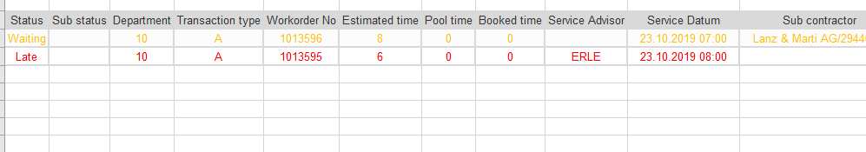

## Grid text color

The text color in the grid is defined by work order visit reason code.

Each line has a visit reason code in field VisitReasonCode => đã thêm trường này

The text color can be found in the master data list (HTML code)

